SRHS Math 9 Mrs. Hayes-O’Hara and Mr. Hopper
Monday April 6, 2020 This contains 6 lessons and each lesson may take up to 2 hours so this may take you 12 hours (or 24 days @ 30 minutes/day and that Is perfectly ok). We all work at different paces. It’s a marathon, not a sprint remember. Accuracy not speed. Email me on Friday to tell me where you have finished for the week please. We can do this!
Welcome back!!! It’s been a long time since our last face to face class on March 13th! I miss you and I bet that you have been missing your favorite class (and the super cool and fun math songs).
Times have certainly changed! Our number one priority continues to be your physical, mental and emotional health.
I recognize that this is a hugely challenging time in our lives and so it is important that you work at your very own pace- just like we were doing in class that last day. Our goal is mastery of solving equations (outcome PR3), not speed. The Minister of Education has recommended 2.5 hours per day of school at the grade 9 level, plus 30 minutes of reading and 30 minutes of physical activity. I know that you have multiple courses and additional home responsibilities so please try to aim for 30 solid minutes of math, if you can, at any time of the day. I am aware that many of you are sharing a computer with your siblings, others have internet that is less reliable and some of you are caring for your younger siblings. You may not be in school but, many of you are just as busy with responsibilities at home and have hopefully learned a whole new skillset (cooking, cleaning, organizing, farming, babysitting). We know that learning happens both inside and outside of the classroom. You are doing great! You are already learning patience and perseverance and resilience and compassion and wellness and technology… statistics on this virus, what a bell curve looks like, exponential growth… #stayhome #socialdistancing
#flattenthecurve Together, we can do this!
If you need any assistance, I am only an email away. stacey.hayes@nbed.nb.ca luke.hopper@nbed.nb.ca
Email me every Friday please to tell me where you have finished off for the week.

This is probably THE most important outcome of this term, so we are going to practice, practice, practice so you are ready for NRF (Math 10) next year! You’ve got this!
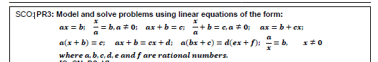

Lesson #1
When we left off, everyone was on a different question from sheet F, G, H, I or J. (Luckily, I recorded where each of you were at the end of class on March 13th ). Because it’s been a while, let’s all start with a warmup review of what we already know: add, subtract, multiply and divide single step equations and solving 2 step equations with adding, subtracting, multiplying and dividing and simplifying. And remember… 1. Copy the question. 2. Show all your work. 3. Keep your equal signs in a nice straight line 4. Circle your final answer and… 5. VERIFY your work (By doing that, you’ll know you have the correct answer). ***Number this page 40 B in your notebook
- x+2= -17
- x - 8= 9
- -2x = -10
- $\frac{x}{3}$ = -8
- $2x+8= -22$
- $\frac{x}{2}$ – 8=16
- $x+x+x+10=21+7$
- Did you verify questions #1-7?... Did your verifications work? If yes, YAY! Move on to lesson #2. If no, did you make the corrections? (If not, do so now and then move on to lesson #2)
If you need any assistance, I am only an email away. stacey.hayes@nbed.nb.ca luke.hopper@nbed.nb.ca

**Here is a video example of the basic process just so you can check it to make sure you remember!
https://youtu.be/e2Dnl8bACSM
And here is a quick video to remind you of how to do your verification
https://youtu.be/mujc6ao6Kh4
See below for the answers to check your work once you have completed and verified the 7 questions above.
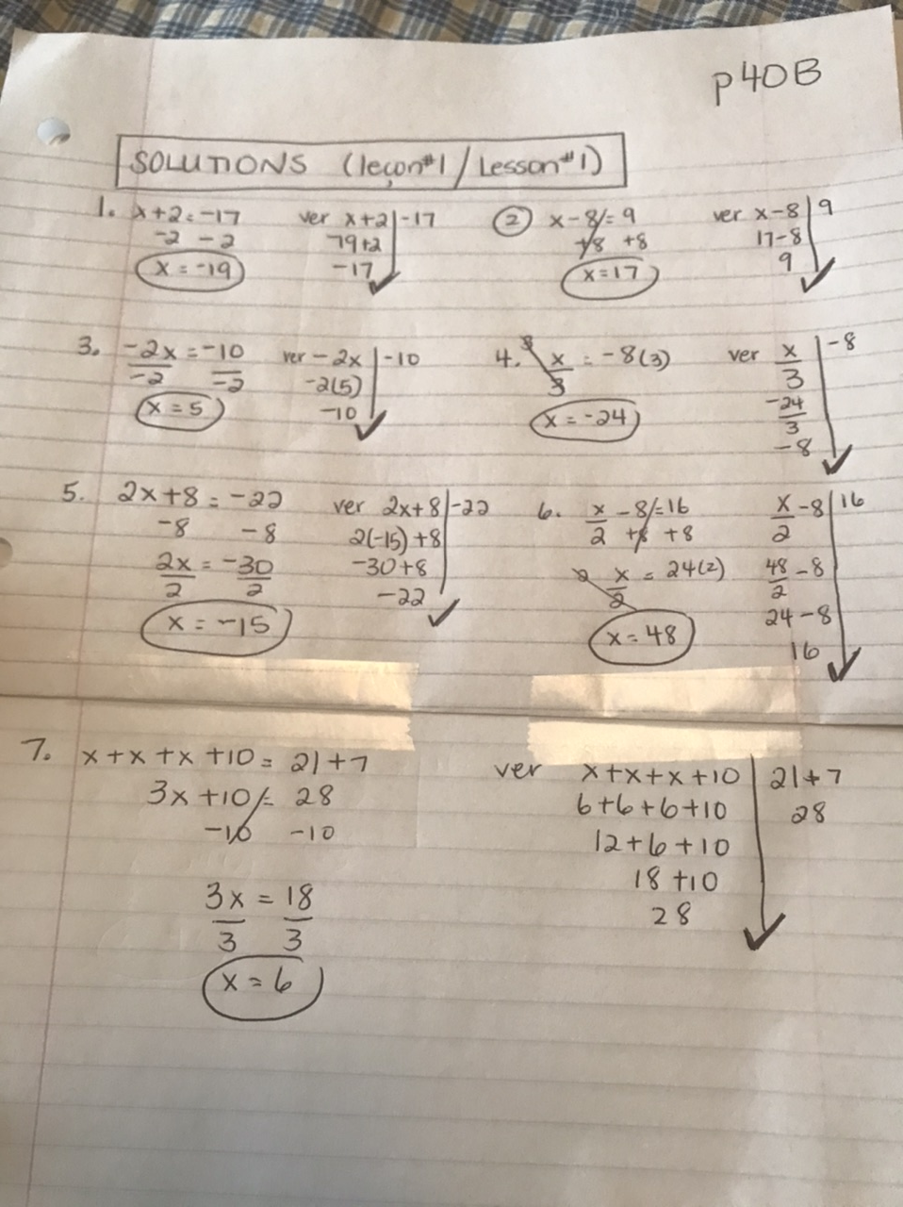

Lesson #2
Many of you were working on page F. (That worksheet with F, G, H, I, and J is p.41 in your notebooks, and there is a pic of it at the top of my webpage and just under this.) https://shayeshomework.weebly.com/
The goal of section F was to be able to: Simplify each side of the equation (when possible), before solving for x (or the variable).

Ex #1 3x + x -2x +6= 12 -4 +8 #1. Simplify each side of the equal sign
4x – 2x +6= 16
2x+6= 16 #2. Move the number that isn’t “stuck” to your x, first.
-6 -6
2x = 10
÷2 ÷2
x=5
**When you verify this, you will need to substitute every x in your original question with the 5. If the left side equals the right side, you have it! 3x + x -2x +6 | 12 -4 +8
3(5) +5 -2(5) +6| 8+8
15 + 5 – 10+6 | 16 BEDMAS remember
20-10 +6 | 16
16 | 16

For video help on this form of question please view the video in lesson one and watch the final example. The verification video also shows how to verify questions like these ones.

Work on and complete page F. This will take multiple days. Start where you left off and remember everyone needs to work at their own pace. And remember… 1. Copy the question. 2. Show all your work. 3. Keep your equal signs in a nice straight line 4. Circle your final answer and… 5. VERIFY your work (By doing that, you’ll know you have the correct answer). ***Number this page 42 for your notebook. Once you have successfully completed F, move on to lesson #3.
If you need any assistance, I am only an email away. stacey.hayes@nbed.nb.ca luke.hopper@nbed.nb.ca
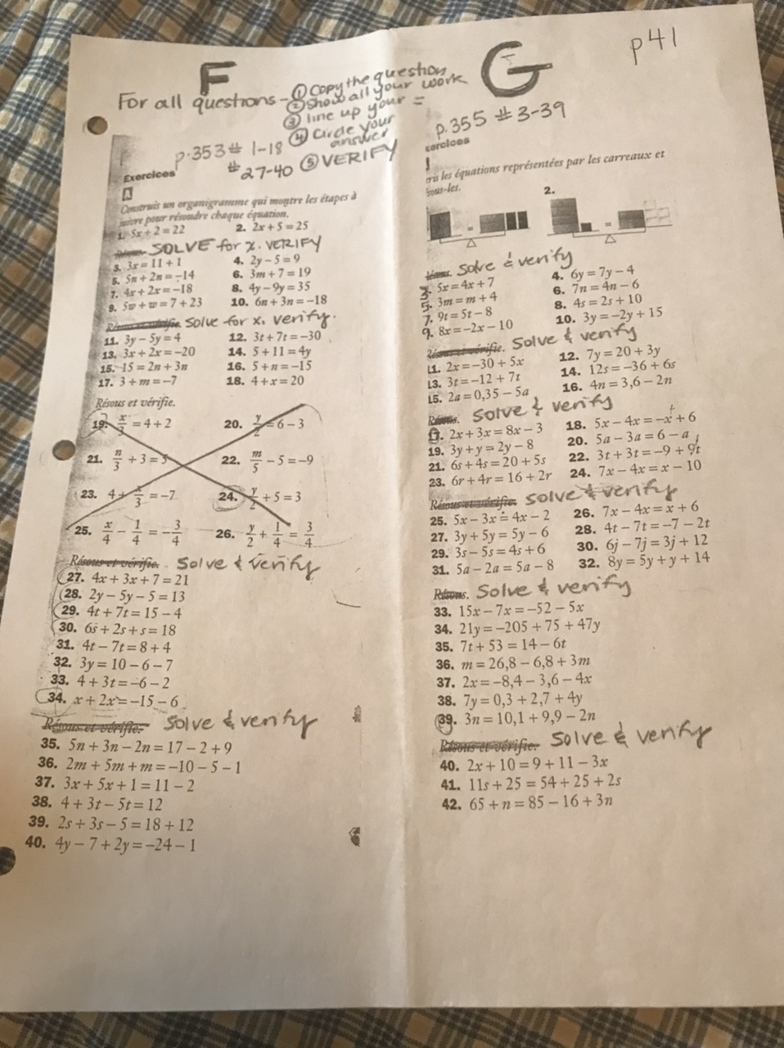

Lesson #3:
Sheet G: Variables on both sides of the equal sign. (p. 41 of your notebook or there is a pic at the top of my webpage and above this in lesson 2)
We are just adding one new step and one that we saw in class already. What do we do when we have x on both sides of the equal sign? Easy rule of thumb- letters on the left, numbers on the right… and remember what you do to one side you must do to the other.

Ex. 6x= 5x +2 #1 Can we simplify each side? Not in this case, already simplified
-5x -5x #2. Move the x on the right to the left. What’s the oppose of +5x? -5x
x=2

verify your answer
6x | 5x+2
(6)(2) | (5)(2) +2
12 | 10+2
12 | 12

For video help on question with variables on both sides of the equation, please click here:
https://youtu.be/F8cLnoCCaM0

Work on and complete G. This will take multiple days. Start where you left off and remember everyone needs to work at their own pace. And remember… 1. Copy the question. 2. Show all your work. 3. Keep your equal signs in a nice straight line 4. Circle your final answer and… 5. VERIFY your work (By doing that, you’ll know you have the correct answer). ***Number this page 43 for your notebook. Once you have successfully completed G, move on to lesson #4.
If you need any assistance, I am only an email away. stacey.hayes@nbed.nb.ca luke.hopper@nbed.nb.ca

Lesson #4
Page H. Distributive Law (just a fancy way of saying a number in front of brackets and… we already saw this during our study of polynomials--- Always get rid of your brackets before you simplify and THE TRICK IS IN THE ARROWS!! (H is P.41 of your notebooks and there is a pic of it at the top of my webpage and just below this)

Ex -3(x+2)= -18 #1. Get rid of your brackets. THE TRICK IS IN THE ARROWS.
**You need to multiply what is outside of the brackets by each term inside the brackets… just like we did with polynomials.
-3x -6= -18 #2 Now this is an easy two step equation that we solved on pages D and E and F.
+6 +6
-3x = -12
÷-3 ÷3
x = 4

verify -3x -6 | -18 Recopy the original question
-3(4) -6 | -18 Substitute x with your answer above 4
-12-6 | -18
-18 | -18 When the left side equals the right side, our verification works, and we know we found the correct answer for x.

For help with algebraic equations containing Distributive Law please click here:
https://youtu.be/isUAf1i0hvg

Work on and complete H. This will take multiple days. Remember everyone needs to work at their own pace. And remember… 1. Copy the question. 2. Show all your work. 3. Keep your equal signs in a nice straight line 4. Circle your final answer and… 5. VERIFY your work (By doing that, you’ll know you have the correct answer). ***Number this page 44 in your notebook. Once you have successfully completed H, move on to lesson #5.
If you need any assistance, I am only an email away. stacey.hayes@nbed.nb.ca luke.hopper@nbed.nb.ca

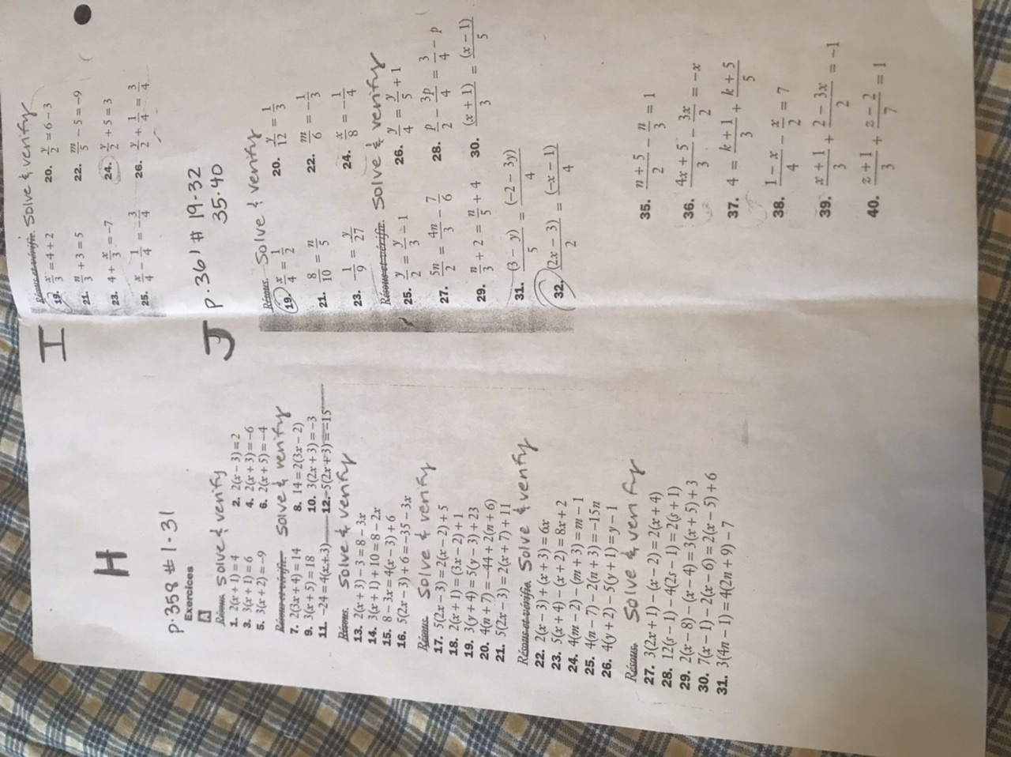

Lesson #5. Section I: Equations with fractions
Firstly, we never want to change a fraction to a decimal. If is isn’t a terminating decimal, you are rounding off and your answer is less precise than if it were written as a decimal.
Ex. 1/3 = 0.33333333333333333333333333333333333… not simply 0.33
Let’s begin with the easy ones- one single denominator
$\frac{x}{2}$ + 10 = -22 First way to do this… but this way will only work with 1 denominator
Think of it as a basic 2 step equation… move what isn’t stuck to the x first.
-10 -10
$$\frac{x}{2} = -32$$
x2 x2 ****remember that you are multiplying the numerator by this number
$\frac{2x }{2} = -64$ Now that you have done the multiplication, just divide ($\frac{2x}{2}$)
x = -64

now verify:
$\frac{x}{2}$ + 10 | -22
$\frac{-64}{2}$ + 10 | -22
-32 + 10 | -22
-22 | -22 the left side equals the right side, so we have proved x= -64

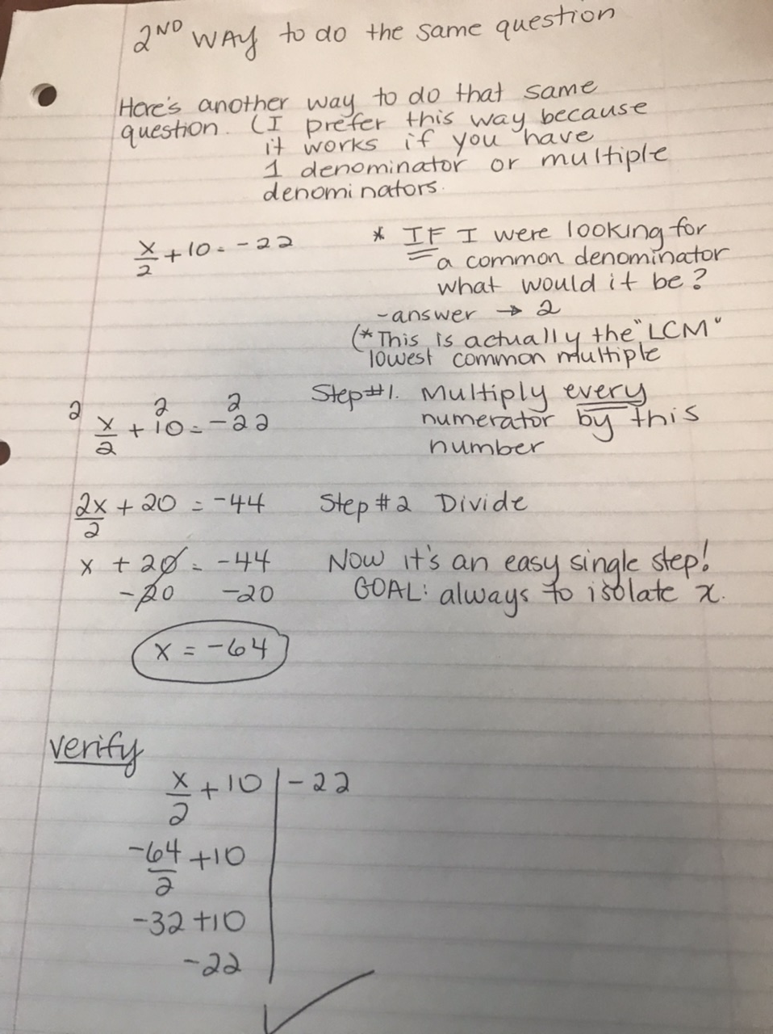
For a video example of how to do equations with single fractions please click here:
https://youtu.be/ua7HlmSBT8Y
Work on and complete I #19-24. Remember everyone needs to work at their own pace. And remember… 1. Copy the question. 2. Show all your work. 3. Keep your equal signs in a nice straight line 4. Circle your final answer and… 5. VERIFY your work (By doing that, you’ll know you have the correct answer). ***Number this page 45 in your notebook. Once you have successfully completed I #19-24, move on to lesson #6.
If you need any assistance, I am only an email away. stacey.hayes@nbed.nb.ca luke.hopper@nbed.nb.ca
Lesson #6: ENRICHMENT. Section I #25,26 and J: Multiple denominators (questions are on page 41 of your notebook, on my website and posted in lesson 4 above)
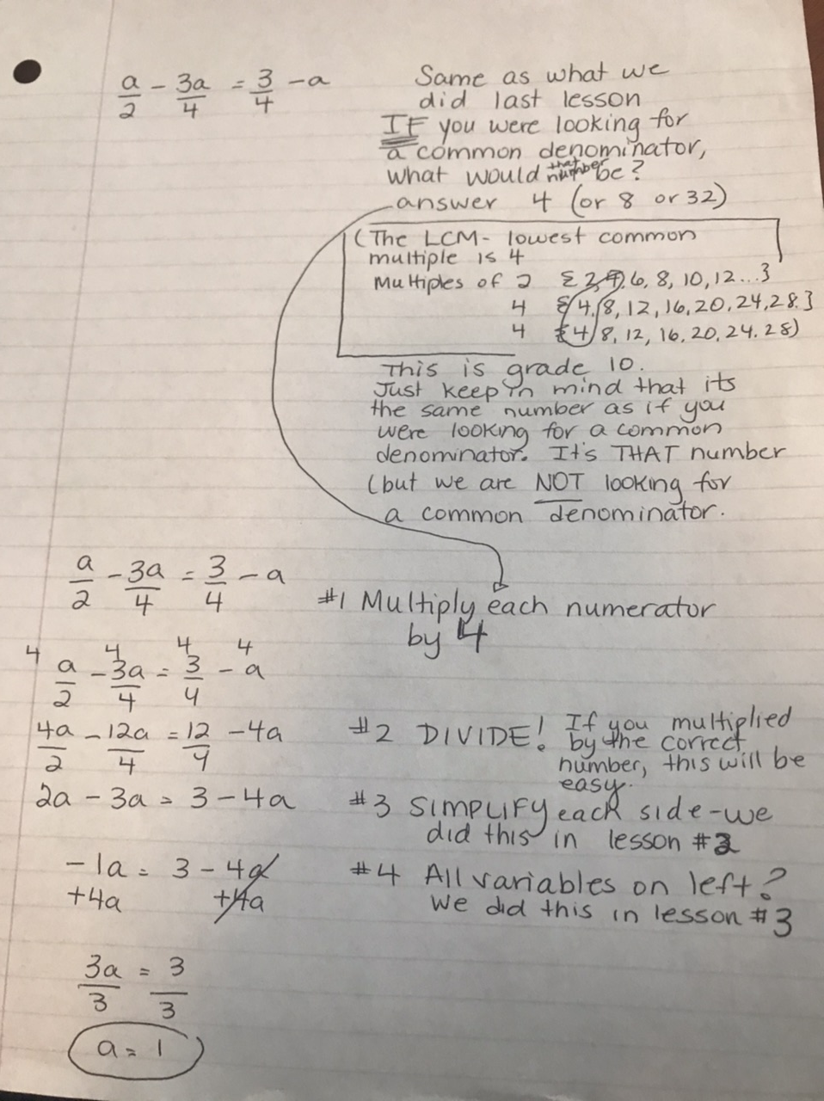

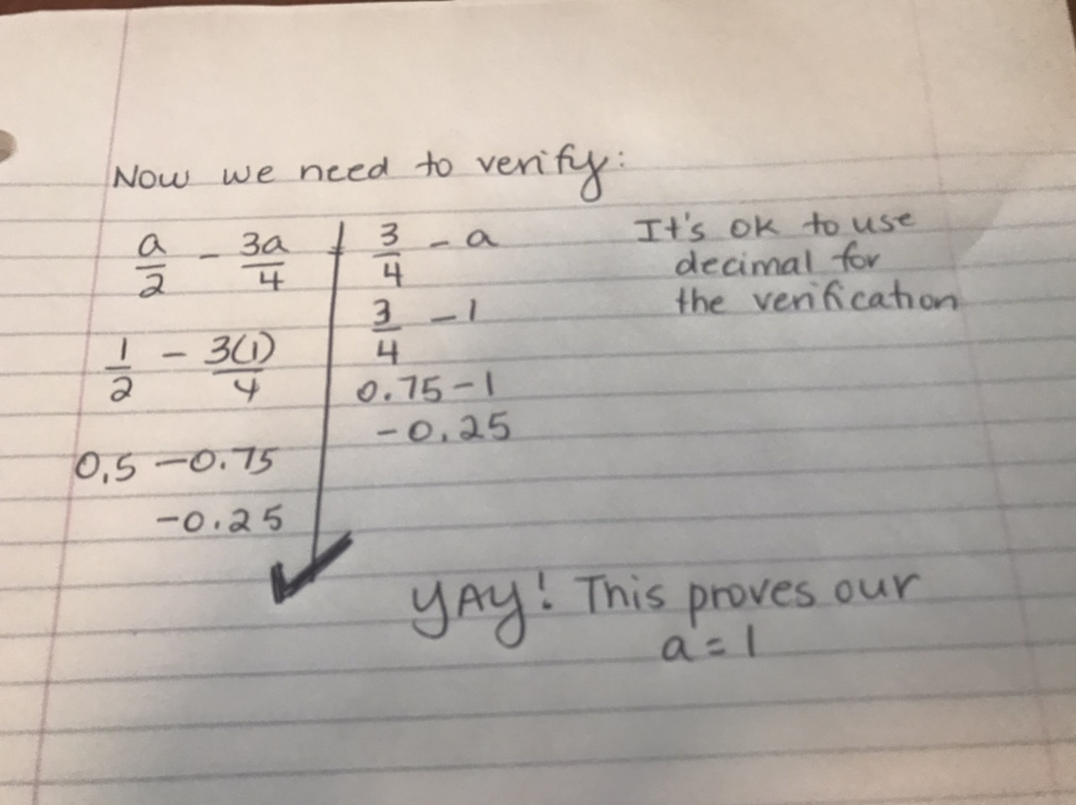
Click here to see a step by step example of doing algebraic equations with multiple denominators:
https://youtu.be/WFWRSfG1fTk
Click here to see the verification for the video question from directly above:
https://youtu.be/RnYAtAIYJ5k
Work on and complete I #25-26 and J. These are long!!! And fun! Take your time and like the others, this section will take days. Remember everyone needs to work at their own pace. And remember… 1. Copy the question. 2. Show all your work. 3. Keep your equal signs in a nice straight line 4. Circle your final answer and… 5. VERIFY your work (By doing that, you’ll know you have the correct answer). ***Number this page 46 in your notebook. Once you have successfully completed I and J, move on to lesson #7.
If you need any assistance, I am only an email away. stacey.hayes@nbed.nb.ca luke.hopper@nbed.nb.ca
Now you know why we absolutely LOVE equations. Follow the steps. Verify. And… when your verification works, you know that you got the correct answer! And.. you were self-paced and self motivated and I’m so proud of you!
Lesson #7… a variable in the denominator.

