Lesson #38
Circle Geometry: Property #1

SS1: Solve problems and justify the solution strategy using circle properties including:
• the perpendicular from the center of a circle to a chord bisects the chord
• the measure of the central angle is equal to twice the measure of the inscribed angle subtended by the same arc
• the inscribed angles subtended by the same arc are congruent
• a tangent to a circle is perpendicular to the radius at the point of tangency.

- Watch the YouTube lesson https://youtu.be/fY6fb4bUM8A

- Complete the following questions in your notebooks on page 79 or 79 b or 79c.

1. Explain the following terms with a drawing:
- Chord
- Radius
- Diameter
- Midpoint
- perpendicular

2. Find the missing angles and sides:
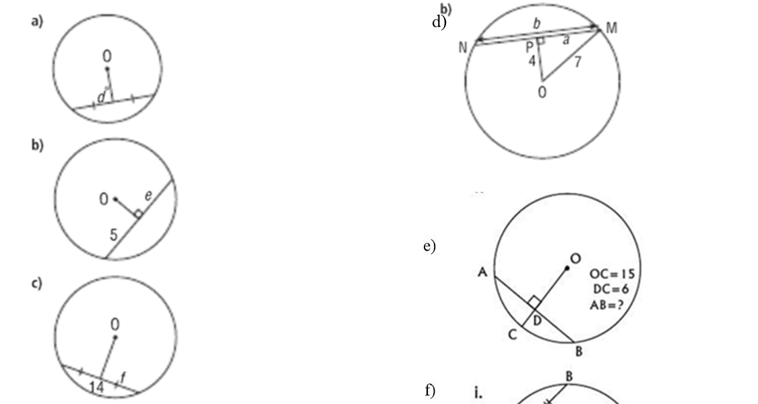
- Explain the Pythagorean Theorem.

- A) Explain circle property #1 in your own words.

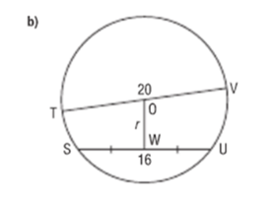

When you have finished, correct your answers.
