Lesson #36
SS1: Solve problems and justify the solution strategy using circle properties including:
• the perpendicular from the center of a circle to a chord bisects the chord
• the measure of the central angle is equal to twice the measure of the inscribed angle subtended by the same arc
• the inscribed angles subtended by the same arc are congruent
• a tangent to a circle is perpendicular to the radius at the point of tangency.
Circle Properties #2 and 3

- Watch the YouTube lesson: https://youtu.be/YdVt-0JpGjg

- Complete the following questions on page 77B or 77C in your notebooks:

- Explain the following terms in your own words or using a drawing:
a) central angle-
b) inscribed angle-
c) Circumference-
d) Arc
e) right angle
f) diameter-
g) radius-

- Find the missing angles. Note how you found that answer. Was it circle property #2 (central angle and inscribed angle) or circle property #3 (inscribed angles subtended by the same arc)?
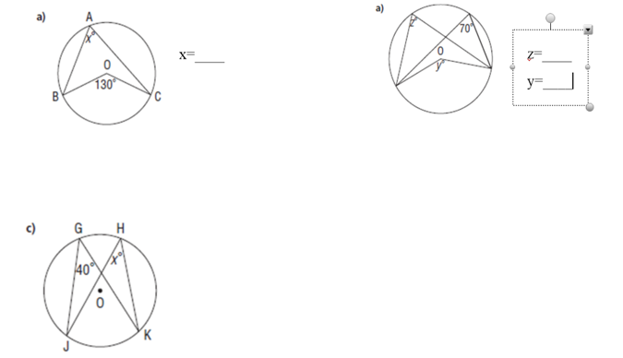
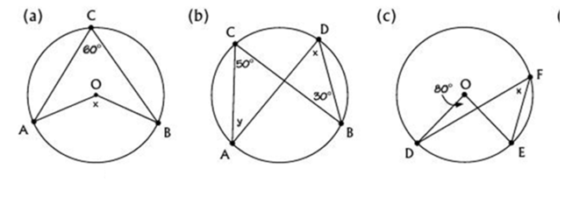
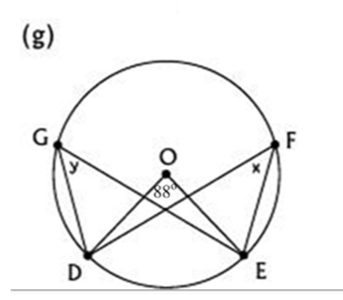

Correct your answers with mine below.
