Lesson 34
SS5: Demonstrate an understanding of line and rotational symmetry.
Rotations.

We all know what a rotation is. It is something that turns. Picture a wheel on a school bus. Think of the carousel at the Balloon Fiesta last year. Think of a ferris wheel, a clothesline pulley, a fan… Things turn!

Write down everything you see below in yellow in your notebooks on page 75.

A full turn is how many degrees? 360 degrees. *Think of a circle. It measures 360 degrees.

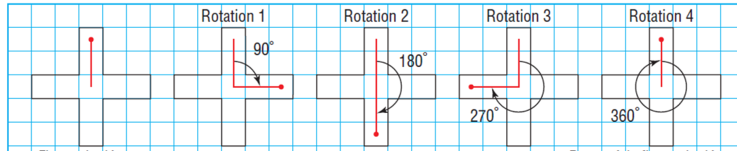

The ORDER of rotation is how many times an object will coincide or turn over itself. Every object has an order of rotation of 1. If you lay me on the floor and turn me around 360 degrees, I will be back where I started. A true rotation will have an order of rotation of 2 or more in one single rotation of 360 degrees.
You can see in the t shape above that the order of rotation is 4 as the t covers itself 4 times in a 360 degree rotation; once at 90 degrees, a second time at 180 degrees, a third time at 270 degrees and a fourth time at 360 degrees.
If we were in class, I would give you a transparency and a dry erase marker and we would trace the original and , using our pencils, hold it at a point and rotate it 360 degrees clockwise to find the order of rotation.
We are going to improvise! This pandemic is making us become creative problem solvers. Go round up a sandwich bag (or Ziploc bag) and a marker (sharpie) and a piece graph paper.
This is going to be neat to do remotely. In class, I would have handed out transparencies and markers and we would have traced our original figure and drawn the rotated figure as it went 90 degrees clockwise.
- On your graph paper draw a rectangle that measures 2 units (base) by 5 units (height) like mine below.

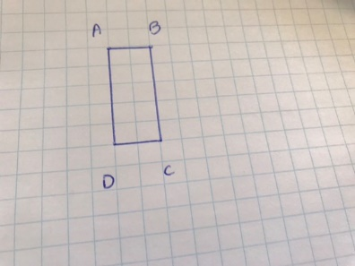

- Now, using your sandwich bag and your sharpie, trace the rectangle. Put a dot at the center.
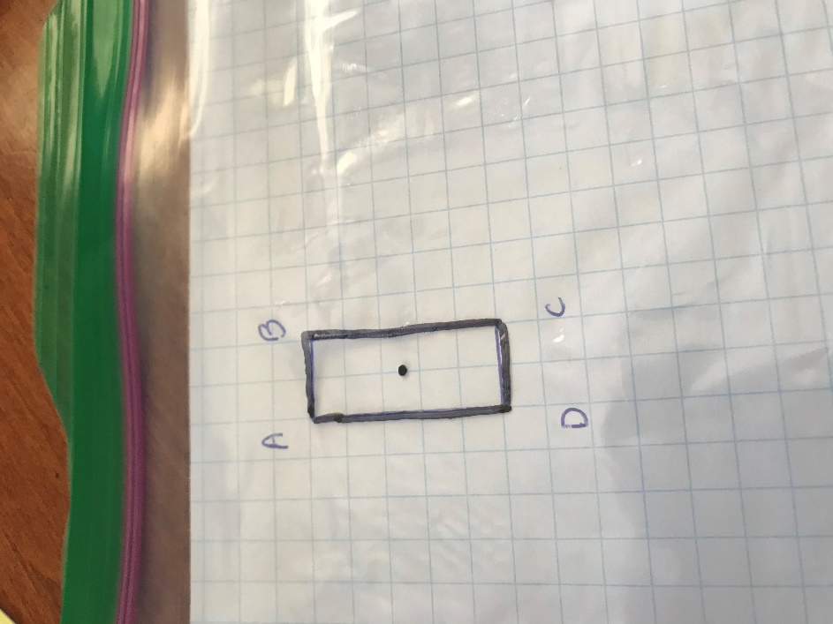

- Now put a mark in the upper left-hand corner so you remember where you started. (Next step is to complete a rotation and I sometimes forget where I have started if I have not marked it).
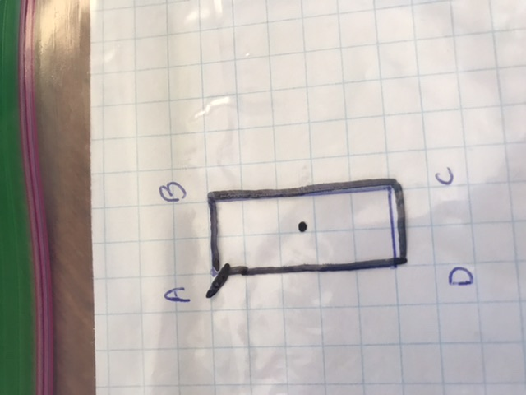

- Using a pen or sharp pencil, hold your tracing (AKA the Ziplock bag that you have traced the rectangle on.)
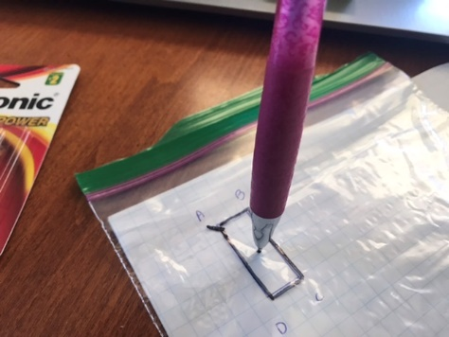

- Now you are going to turn 90degrees clockwise… Does it cover itself (perfectly)?... NO!
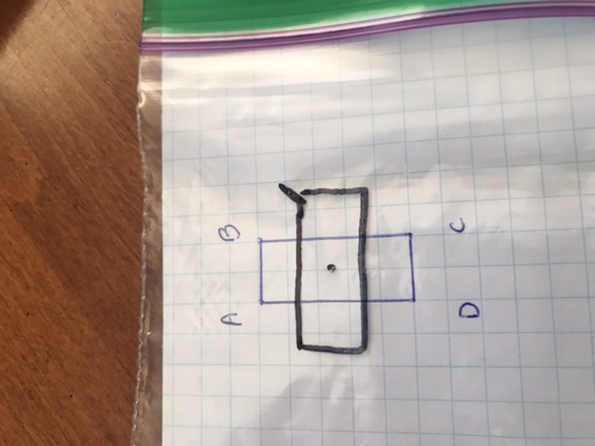

- Now go 90 more degrees clockwise. (You have now gone 180 degrees total). Does it cover itself/ coincide with itself? YES!!!
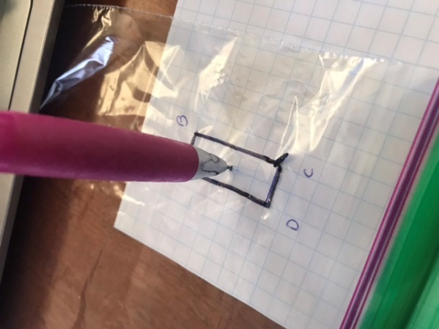

- Now go another 90 degrees clockwise. (You have now gone 270 degrees total). Does it cover itself completely? NO!!!
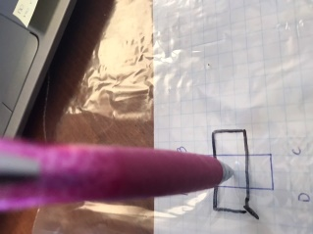

- Now turn another 90 degrees clockwise. (You have now made a complete rotation 90+90+90+90= 360 degrees) and you are now back to where you started. (Notice the mark in the upper left). Does it cover itself? YES!!!

- How many times did it cover/coincide with itself during that 360-degree rotation?
TWICE. So, your order of rotation is 2
- Now calculate the angle of rotation. Angle of rotation= 360 degrees ÷ order of rotation
360/2= 180 so the shape coincides with itself every 180 degrees

- Your turn on your own. Draw a square on your graph paper that is 2 units x 2 units. Trace it on your sandwich bag. Make a 360-degree rotation.
- What is the order of rotation and why?
- What is the angle of rotation and why?

The order of rotation is 4 as it will coincide with itself 4 times in a 360-degree rotation.
The angle of rotation is 360 degrees/4= 90 degrees. It covers/coincides with itself every 90 degrees.

- Next is my YouTube lesson. This activity should make my lesson easier to follow! Enjoy!
https://youtu.be/QNPgjR7p9S0

