Lesson 33
Line Symmetry (Reflections)
SS5: Demonstrate an understanding of line and rotational symmetry.

Time for practice. Yesterday, we learned about line symmetry and reflections. Together, we practiced how to do reflections of triangles about the x or y axis on graph paper. Today, you will complete questions just like those on your own on p. 74 of your notebook. (If you forget what to do, look on page 73 of your notebook and the work you did yesterday or watch lesson 32 again).

#1. You will need graph paper. If you do not have any, or can’t print any, do the best that you can and make your own by drawing vertical lines on your loose-leaf.

#2. Complete the following questions on p. 74 of your notebooks.
- Triangle ABC is reflected about the x axis. A (1,6) B (4,1) C (7,8)
Highlight the line of symmetry (x axis). Draw the original figure and the reflected image. (up 5, down 5, left 4 right 4 etc. just like we did yesterday). ***Remember to label your points A, B, C and A’, B’ and C’.
Write the new coordinates for A’, B’ and C’

AFTER, you have finished this question, scroll down and check your answer with mine below before doing the next questions so you know that you are on the right track.
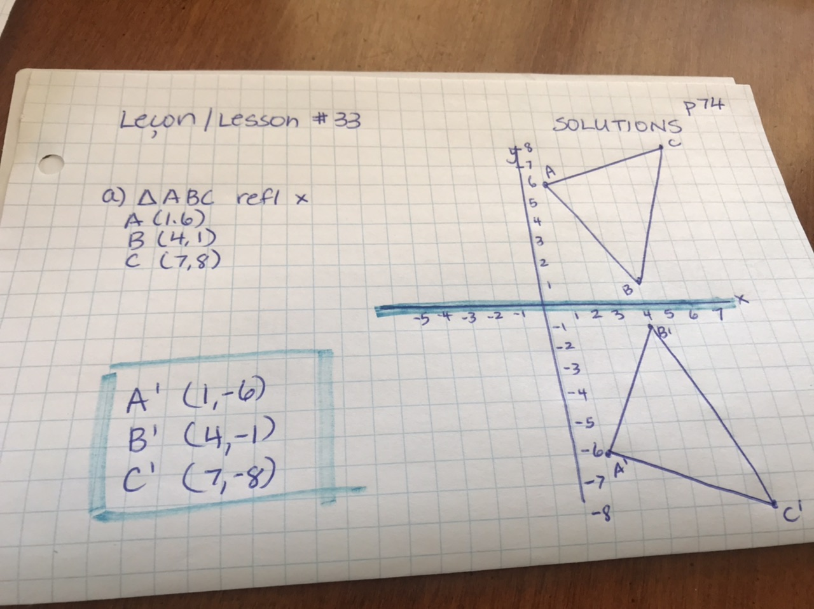

- Triangle ABC is reflected about the y axis. A (1,6) B (4,1) C (7,8)
Highlight the line of symmetry (y axis). Draw the original figure and the reflected image. (up 5, down 5, left 4 right 4 etc. just like we did yesterday). ***Remember to label your points A, B, C and A’, B’ and C’.
Write the new coordinates for A’, B’ and C’
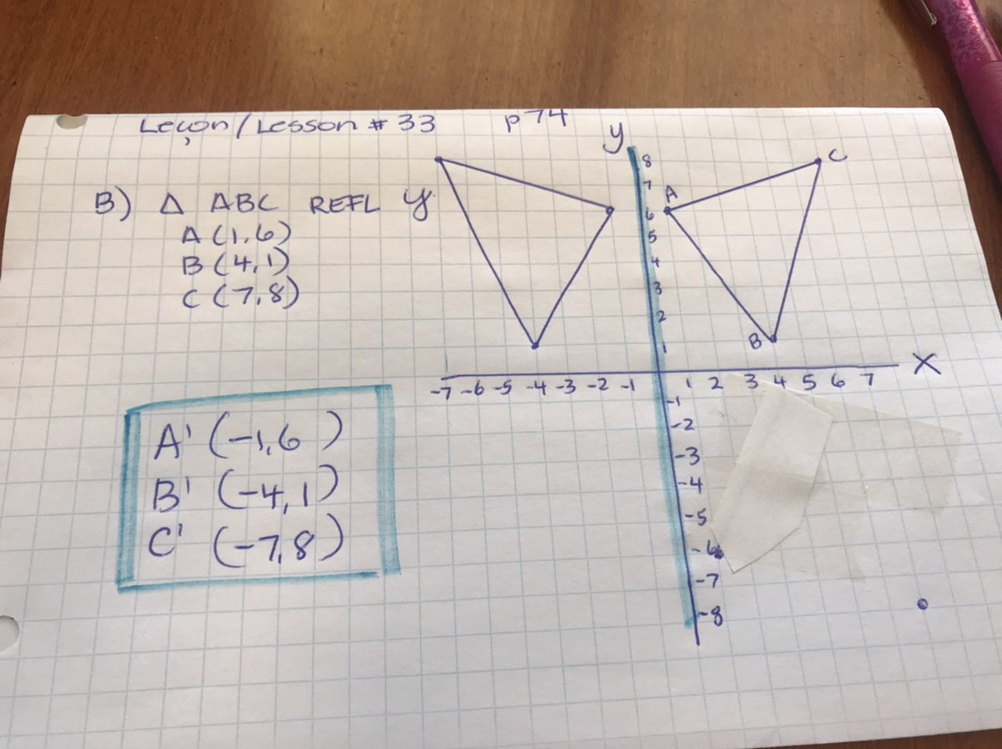

- Quadrilateral ABCD is reflected about the x axis. A (-1,6) B (-4,6) C (-4,2) D (-1,2)
Highlight the line of symmetry (x axis). Draw the original figure and the reflected image. (up 5, down 5, left 4 right 4 etc. just like we did yesterday). ***Remember to label your points A, B, C and A’, B’, C’ and D’.
Write the new coordinates for A’, B’, C’ and D’.
- Quadrilateral ABCD is reflected about the y axis. A (-1,6) B (-4,6) C (-4,2) D (-1,2)
Highlight the line of symmetry (y axis). Draw the original figure and the reflected image. (up 5, down 5, left 4 right 4 etc. just like we did yesterday). ***Remember to label your points A, B, C and A’, B’, C’ and D’.
Write the new coordinates for A’, B’, C’ and D’.
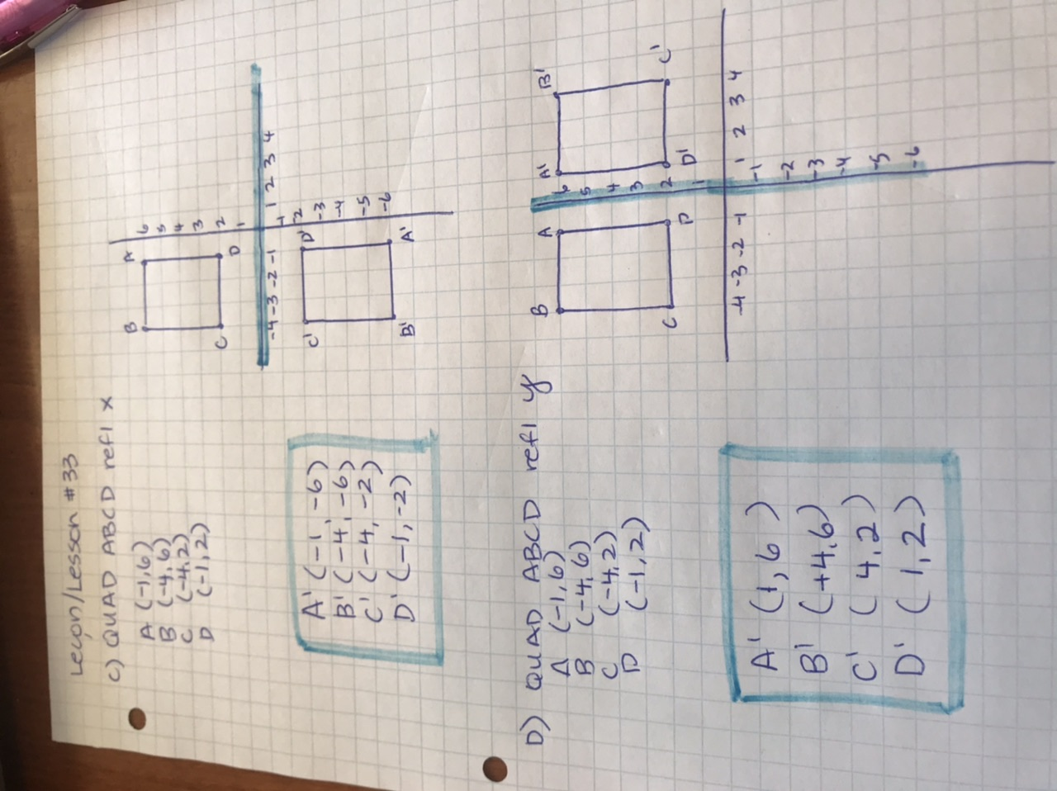

Should you ever have any comments, questions or concerns, know that I am only an email away. Continue to push yourself! You are almost done this course! This outcome and one more and then you will have studied EVERY outcome in the grade 9 Math curriculum!
Stacey.hayes@nbed.nb.ca luke.hopper@nbed.nb.ca

