Lesson 31
SS3: Demonstrate an understanding of similarity of convex polygons, including regular and irregular polygons
- A song- one of my absolute favorites! Listen to EVERY word! It is very smartly written with a ton of math terms, all used perfectly. Ernie and Stu are interesting triangles. Izzy is too. And then there is that scalene who knows how to dance! https://www.youtube.com/watch?v=628eYW4O8hM

- My lesson: https://youtu.be/UagJhg_-kMo

- Practice: 3 questions to complete on page 72 of your notebooks. I am sorry but I do not have digital copy of the textbook in English at home. Only in French. Read the translation to the right please. My apologies.
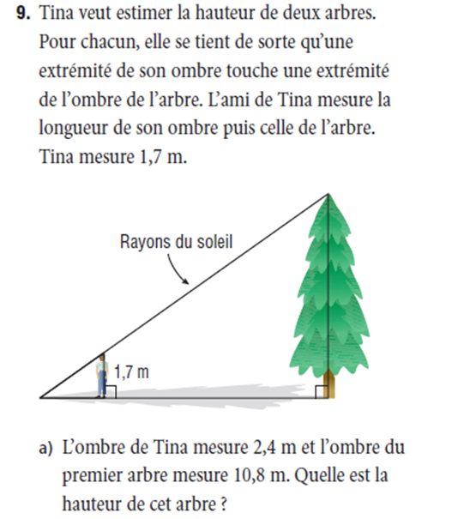 | Tina wants to estimate the height of this tree  Tina recognizes that the end of her shadow touches the end of the tree’s shadow.  Tina’s friend measures the length of Tina’s shadow at 2.4 m and the length of the tree’s shadow at 10.8m.  What is the height of the tree?
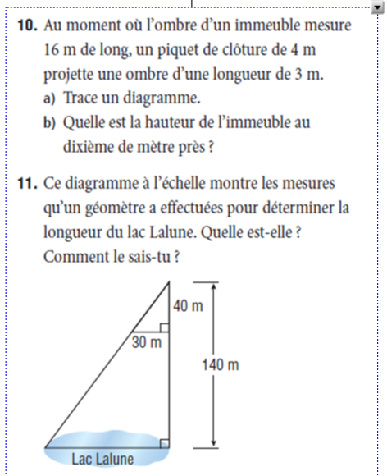 | 10. When the shadow of a building is 16m long, a picket fence that is 4m tall has a shadow that is 3m long.  a) Draw a picture.  b) What is the height (to the nearest tenth) of the building?  11. This scale diagram shows the measurements that a land surveyor used to find the length of Lake Lalune.  What is the length of Lake Lalune? How do you know? (Show all your work).

When you have finished, correct your answers using my answer key below.
