Lesson 30
Complete the following questions in your notebook on page 71. Use your notes if needed. When you have completed the questions, email them to for correction.
Stacey.hayes@nbed.nb.ca Luke.hopper@nbed.nb.ca

- Define polygon.

- Is a triangle a polygon? Explain

- Complete the table, explaining the differences:
 | Similar | Congruent
Angles
Sides
symbol
Scale factor
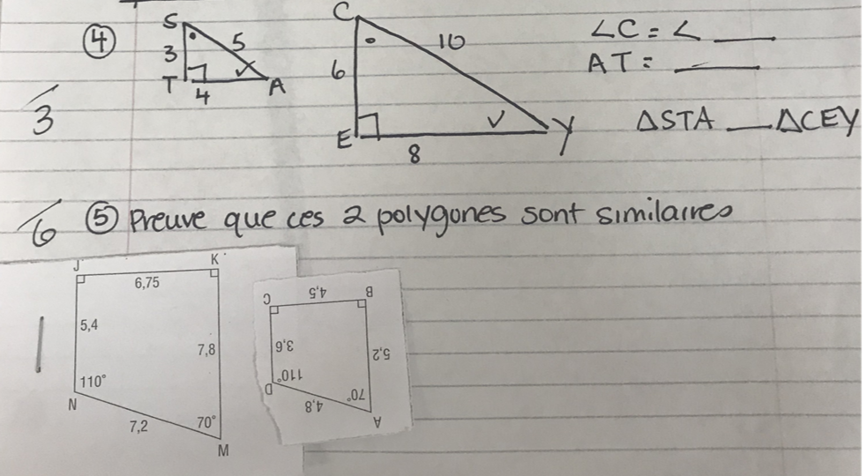
For number 5 above, PROVE that the two polygons are similar. *You need to prove that ALL corresponding angles are equal and ALL corresponding sides are proportional.

