Lesson 28
SS3: Demonstrate an understanding of similarity of convex polygons, including regular and irregular polygons

- Lesson 28 video https://youtu.be/-hnAqCvdtXE

- Activity: This is super cool. You need a sheet of loose-leaf, a pair of scissors and a straight edge (ruler, binder, book etc.) We are going to prove why the sum of the angles of a triangle is 180 degrees!

Step #1. Using your loose-leaf, cut out a triangle that is approximately the size of the palm of your hand. Most of your triangles will be scalene, meaning that all your side lengths will differ. This will also work for isosceles and equilateral triangles (but they are more work to make and cut out).
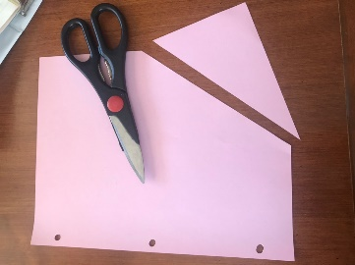
Step #2 Label Inside the angles (the pointy parts) of your triangle A, B and C.
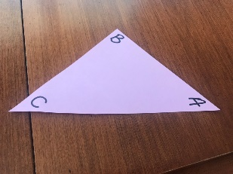

Step #3 Tear off the labelled angles of your triangle
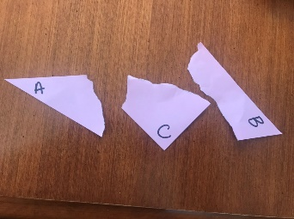
Step #4 Line up your angles (the labelled “pointy” parts) against your flat edge.
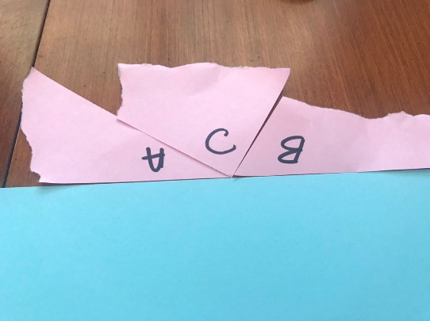
Step #5. A straight line or flat edge measures how many degrees? 180, so these three angles add up to 180.
Step #6. Change the order of your line up of angles. Do they form a straight line?
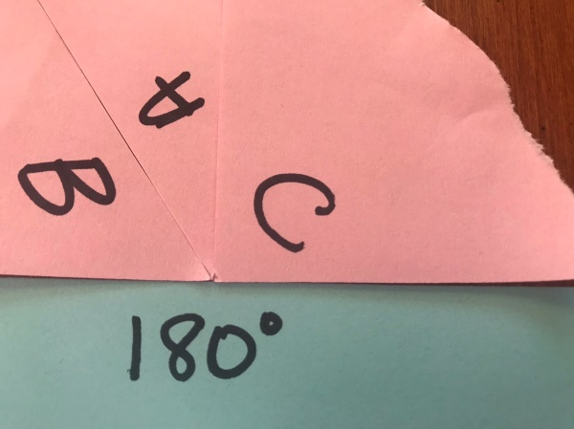
How is that for cool? (I love to do this as a demonstration! It is the only time that I use my overhead projector!)

If I have a right-angle triangle that has another angle that is 30 degrees, I can determine the size of the missing angle! 180- 90 (the right angle)-30 = 60 degrees!

- Let us practice. Complete the following on page 69 of your notebooks.

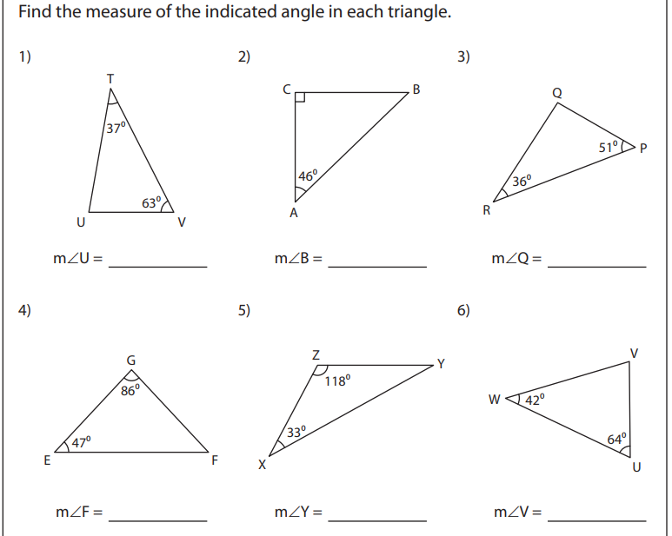
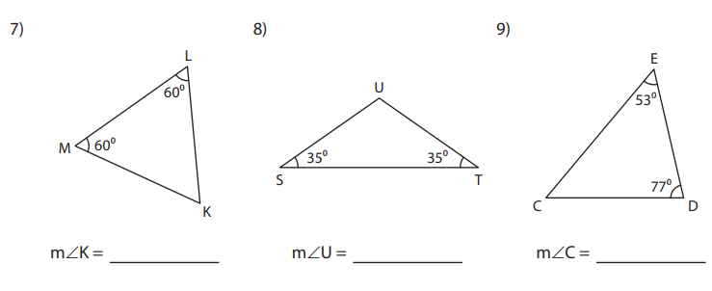

Check your work below when you are finished.
