Lesson 27
SS4: Draw and interpret scale diagrams of 2-D shapes.

- This is not a math song but hopefully it will put a smile on your face and teach you a little bit about scale factor. I am not sure if you are a fan of comedies or not. I am not a big Will Farrell fan; however, this scene is an excellent example of NOT comprehending scale factor. I think we can all use a laugh… about a school for “ants”?...
https://www.youtube.com/watch?v=NQ-8IuUkJJc

***If we multiplied that model by a scale factor of 3, would we be able to fit children in there and teach them how to read?... I should forward my latest YouTube videos to Derek Zoolander. What scale factor would you need for the enlargement that would be big enough to be a regular sized school?

- Pop quiz time. Answer the following in your notebooks on page 68. If you get stuck on a question, refer to your notes.
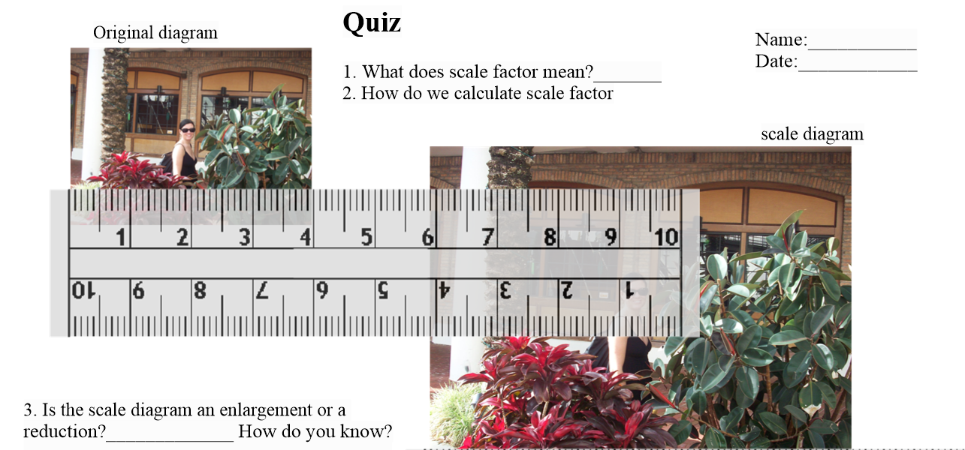
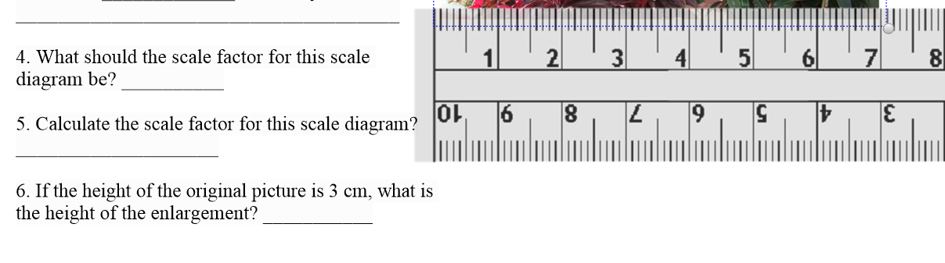

- Check your answers:
- Scale factor means how many times bigger or smaller your scale diagram is compared to your original. Ex a scale factor of 4 means that you have an enlargement 4x the size of your original. A scale factor 0f 0.2 means you have a reduction that is 0.2 or 1/5 the size
- Scale factor= scale diagram ÷ original (*** we need to divide the corresponding sides)
- It’s an enlargement. It is bigger than the original
- The scale factor for this enlargement will be more than one. I would estimate 2.
- SF = SD ÷ original SF= 7cm ÷4cm= 1.75
- If the original is 3cm in height, and the scale diagram is 1.75 times bigger, the height of the enlargement will be 3x1.75= 5.25cm

- In your notebooks on page 68 B, make a page of graph paper. Make an enlargement of this shape, by a scale factor of 2.
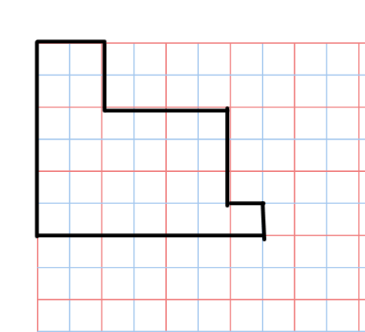
- Check your enlargement with mine. 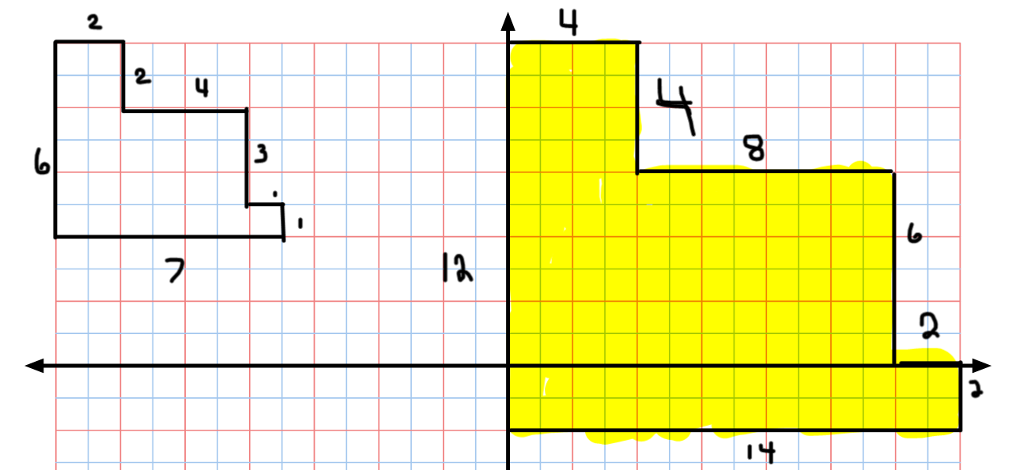

- Tomorrow we are going to begin our study of similarity, commencing with triangles and how to label them. Did you know that a triangle is a polygon? Do you know what a polygon is? Watch this as a warmup for tomorrow’s lesson.
https://www.youtube.com/watch?v=IaoZhhx_I9s

