Lesson #23 Statistics and Probability: GNB
SP5: Demonstrate an understanding of the role of probability in society

Every weekday at 2:30 Premier Higgs and Dr. Russell give a daily update of the COVID-19 pandemic in NB. I have tuned in every day since March 17th and have tracked the data.
March 17th- NB had 8 cases ***total number of confirmed cases that tested positive.
March 19th- NB had 11 cases
March 21st- NB had 17 cases
March 24th- NB had 18 cases
March 25th- NB had 26 cases
March 26- NB had 33 cases
March 27th- NB had 45 cases
March 28th- NB had 51 cases
March 29th- NB had 66 cases
March 30th- NB had 68 cases
March 31st- NB had 70 cases
April 1st- NB had 81cases
April 2nd- NB had 91cases
April 3rd- NB had 95 cases
April 4th- NB had 98 cases
April 5th -NB had 101 cases
Aril 6th- NB had 103 cases
April 7th -NB had 105 cases
April 8th – NB had 108 cases
April 9th -NB had 111 cases
April 12th- NB had 114 cases
April 13th- NB had 116 cases
April 14th- NB had 116 cases
April 15th- NB had 117 cases
April 17th-NB had 118 cases ***total number of confirmed cases that tested positive. As of today, April 30th, NB still has only118 confirmed positive cases of COVID19.

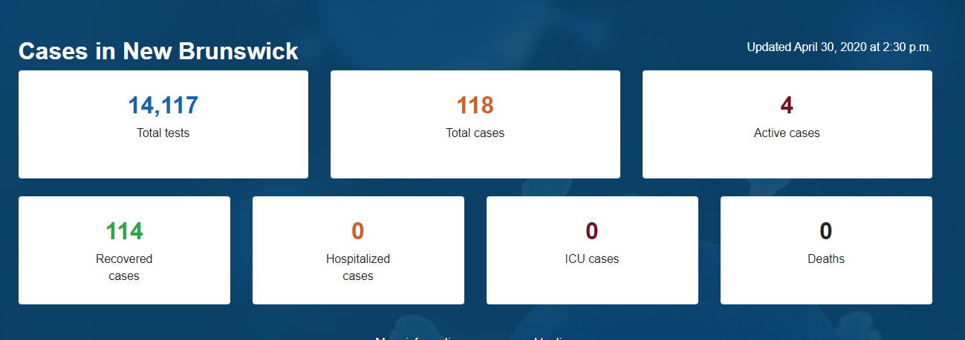

Click on this link to see today’s daily update. https://www2.gnb.ca/content/gnb/en/corporate/promo/covid-19/maps_graphs.html#daily

On page 64 of your notebooks, please answer the following questions in full sentences.
- How many confirmed cases are there now in New Brunswick?
- Active cases refer to cases where individuals are still ill with COVOD-19. There are how many active cases in NB today?
- Recovered refers to cases that are no longer ill. There are how many recovered cases in NB?
- Is this GNB website a good source of valid information? Explain.
- When Dr. Russell announces additional confirmed cases of COVID 19, why does she say an individual aged 30-39 in Zone 3 instead of a 35-year-old man living in Fredericton?
- How many New Brunswickers have been tested for COVID19?
- What age bracket has been the most tested in NB?
- What day did NB have their first confirmed case?
- Looking at the graph of cumulative number of cases, how is New Brunswick doing at present? Is the social distancing and staying home flattening the curve?
Because everyone is working at their own pace, I cannot provide answers here for the questions above because they will change daily.
Scroll down.

Here is the rest of today’s and tomorrow’s lesson (because it will take an hour to complete).
- Watch Dr. Russell and Premier Higgs and listen to today’s update. I go to YouTube at 2:28 and type in Government of New Brunswick and an icon comes up LIVE and I click on that one. It never starts right at 2:30 by the way.
- After Dr. Russell and Premier Higgs are done speaking, journalists have the opportunity to each pose 2 questions in the language of their choice. I love this part because some excellent questions are posed and answered. If you were a journalist, you would want to make the most of that opportunity with 2 excellent questions. In stats and probability lessons #20 and 21 we talked about problems with data collection: use of language, privacy, bias, confidentiality, cultural sensitivity, timing, cost, and ethics. You need to create 2 excellent questions that are worded clearly and concisely that you would pose either Dr. Russell or Premier Higgs or both regarding the COVID19 pandemic in New Brunswick. Send me an email of your 2 questions please.

