Lesson 22: Histograms
SP3: Construct, label, and interpret histograms to solve problems.
We love to use graphs to represent data visually. (Our brains love pictures and color). In middle school, you made lots of bar graphs to display data. This year, we are going to focus on histograms. They look like a bar graph with the exception that there are no gaps between bars. The data is shown as continuous data via intervals.

https://www.mathsisfun.com/data/histograms.html

Here is a summary of what a histogram is:
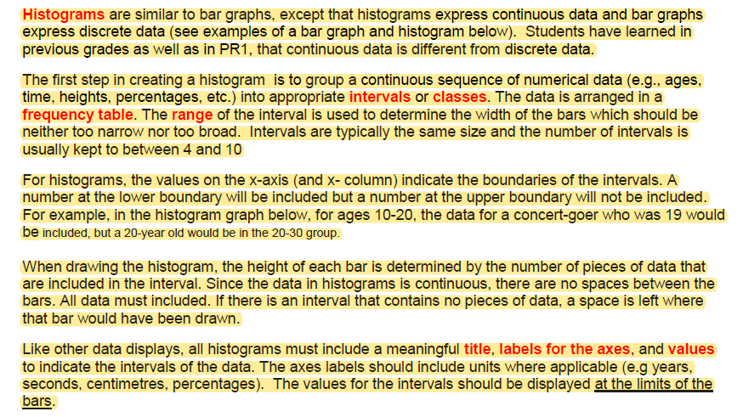

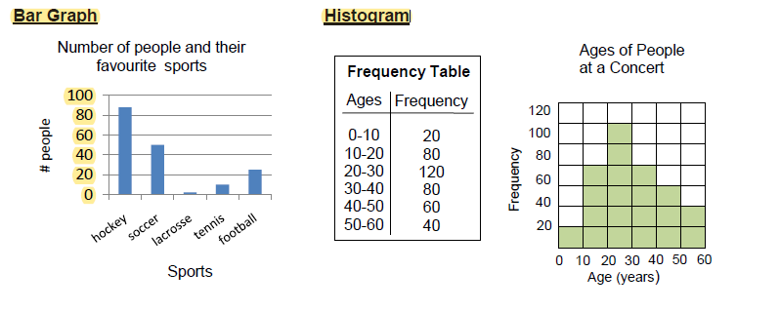
Statistics Canada generates a variety of graphs to display data from the 2016 census. Below, you will see a comparison of population distribution between Sussex and Moncton.

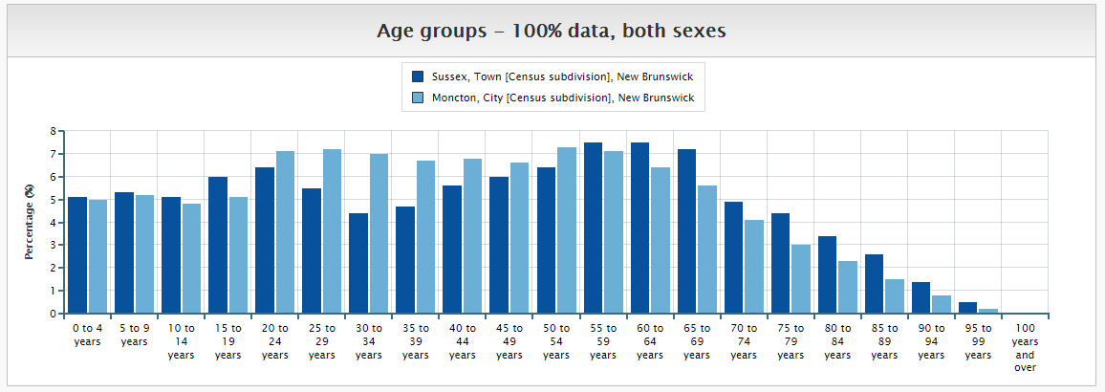

Because this is hard to see, I have attached the link here:
https://www12.statcan.gc.ca/census-recensement/2016/dp-pd/prof/details/page_Figures.cfm?Lang=E&Tab=1&Geo1=CSD&Code1=1305022&Geo2=CSD&Code2=1307022&SearchText=moncton&SearchType=Begins&SearchPR=01&B1=All&TABID=1&type=0

Click on topic and select another one- income, language, housing etc. and click on submit. It is really amazing what you can see and compare. I even changed Moncton to Toronto to Vancouver and made comparisons. The point it, we are surrounded by data. We must ensure that we are always using a valid source of data. The Stats Can data is incredible!

Our New Brunswick Government updates the COVID-19 data daily.
Here is your assignment:
Our New Brunswick government updates the COVID-19 data daily. To date (April 22), there have been 118 confirmed cases of COVID-19 in the province. Create a histogram that displays the number of confirmed cases of COVID-19 in each age category. ***Update: As of April 29th, this data is the same. There have been zero new confirmed positive cases of COVID-19 in the last 11 days!!!!! Our curve has been FLAT for 11 days!
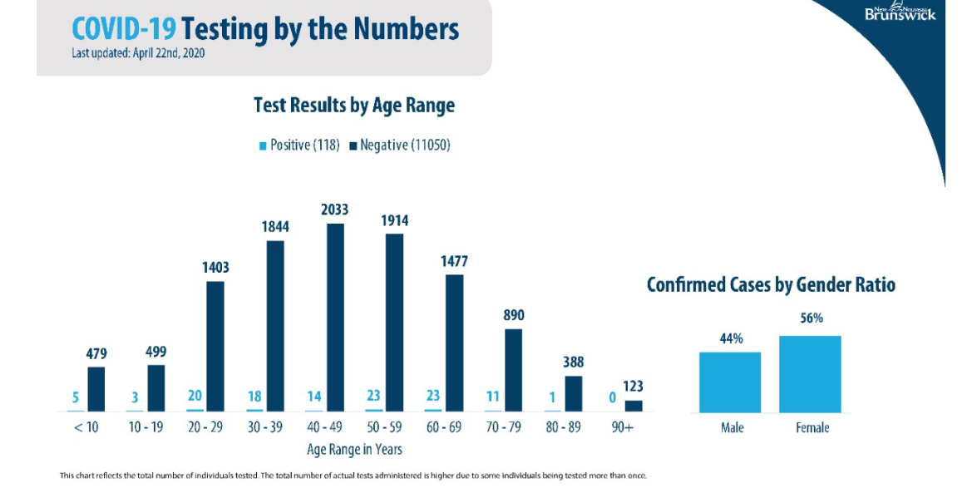
- In your notebooks on page 63, complete the following table, using the graph above, to help you in displaying your data
x axis  Age in years | y axis  # of confirmed positive cases of COVID-19 in NB
0-9 | 5
10-19 | 3
20-29 | 20
30-30 | 18
40-49
50-59
60-69
70-79
80-89
90 plus
TOTAL 118
- If you do not have any graph paper at home, do your best to make some. Draw vertical lines on your loose-leaf. (I know. I do not have graph paper at home either. It is ok. It is non-essential).
- Title your histogram.
- Label and number your x axis (in increments of 10)
- Label and number your y axis
- And, we can check that outcome off our list! Well done and pertinent. We are not displaying data on pizza and favorite classes. We are displaying current valid data from the government regarding the pandemic here in our own province. The goal of this is not to stress you, it is to educate you. NB has fared very well thus far in #flatteningthecurve because of #stayhome and #socialdistancing. Well done!

Check your histogram with mine below.

