Lesson # 21 #flattenthecurve
Stats and Probability (Outcomes SP 1,2,3,4,5,)
Now that we know understand populations and sample sizes, theoretic and experimental probability, how to identify a valid source of information and address concerns of timing, time, confidentiality, cost, cultural sensitivity, language, privacy and ethics, lets dive into better understanding COVID19 and #flattenthecurve

What does “Flatten the Curve” mean?
- We need to understand firstly what is meant by the term “curve.”
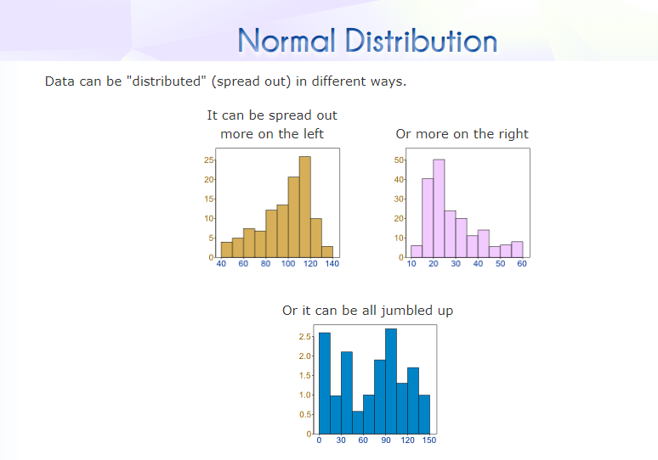
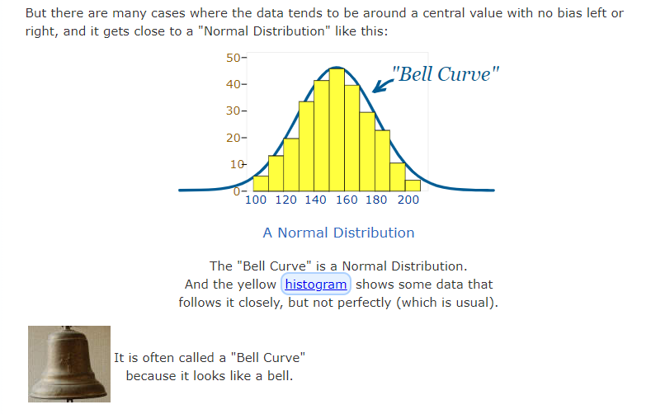

- In your notebook on p.62 please write down your definition of “flattening the curve.”

- Read the following from the GNB website form the Office of Chief Medical Officer of Health
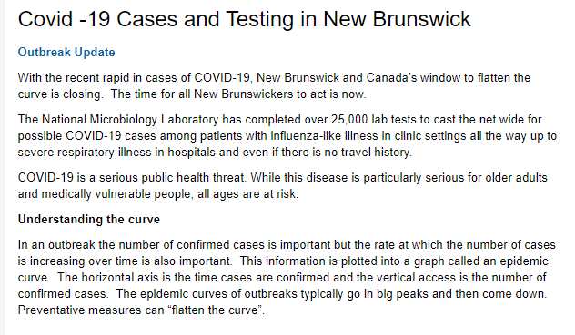

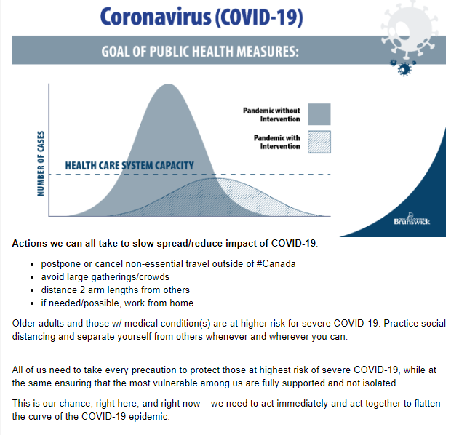

- Watch the following video: https://www.pbs.org/video/what-this-chart-actually-means-for-covid-19-ybsbtd/

- Go back and read the definition you wrote for flattening the curve. Add to your definition what you learned from the video and the GNB information.

- Is New Brunswick succeeding at flattening the curve? Explain in your notebook on p.62. Where did you find your information? Would you consider this a valid source?

- I copied the following from The Globe and Mail online on April 15th. If you only looked quickly at these three graphs: a) Which province seems to be the least successful in flattening the curve? b) What is the biggest difference in NB and BC graphically below?
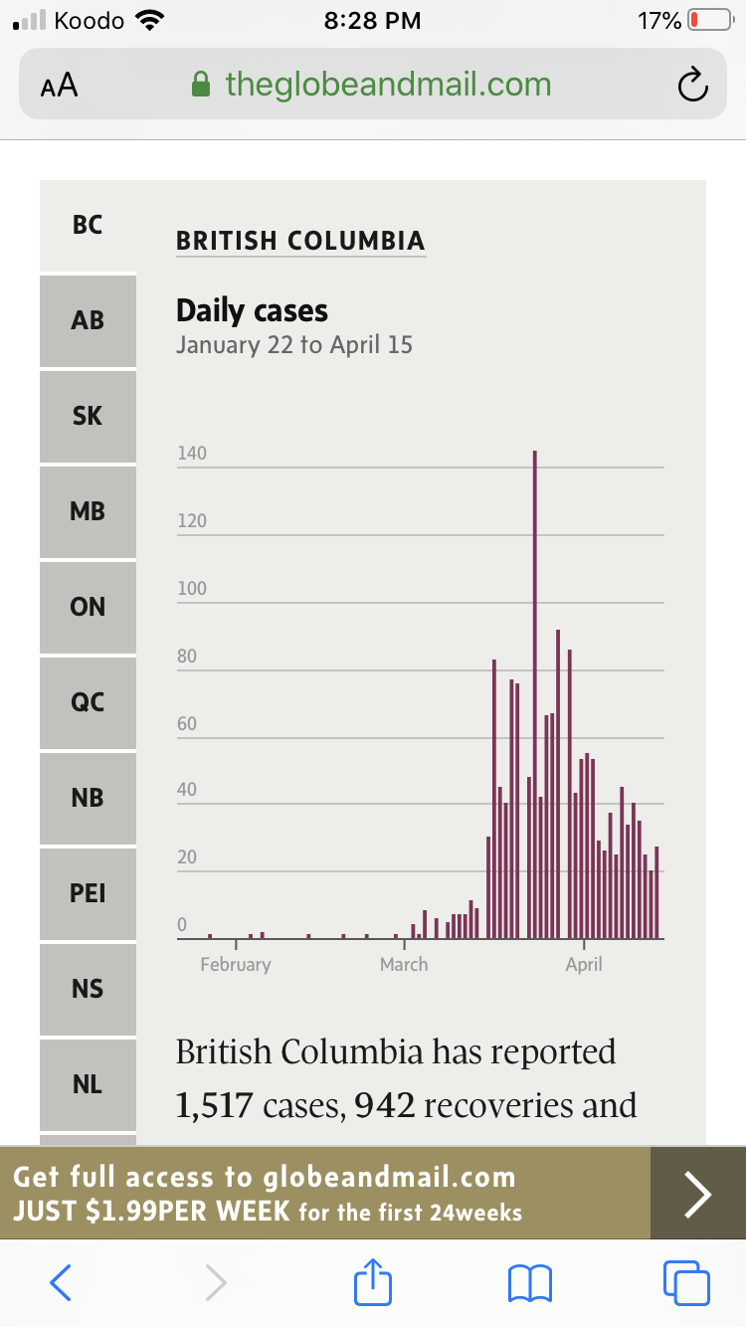

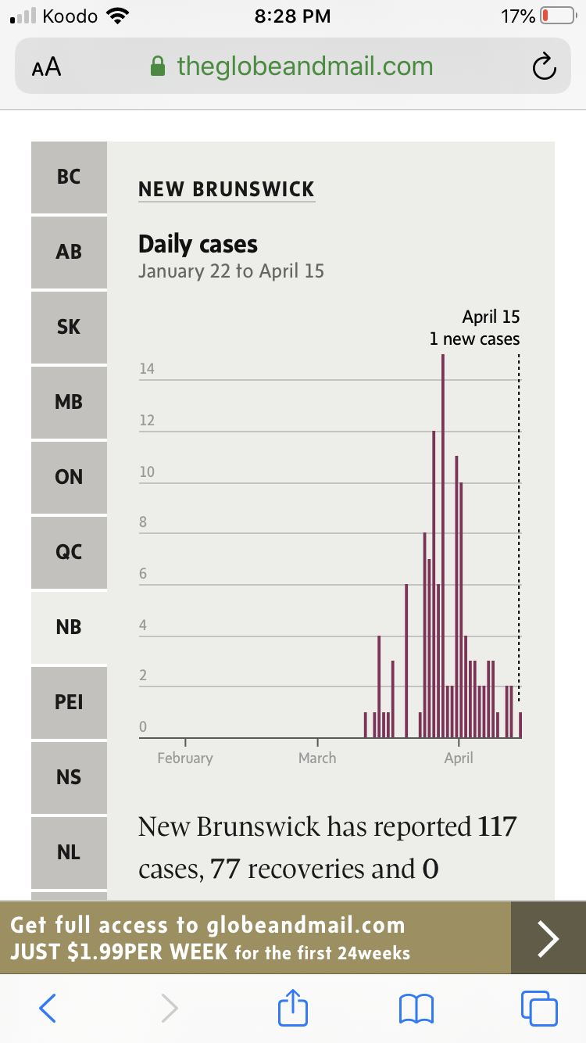
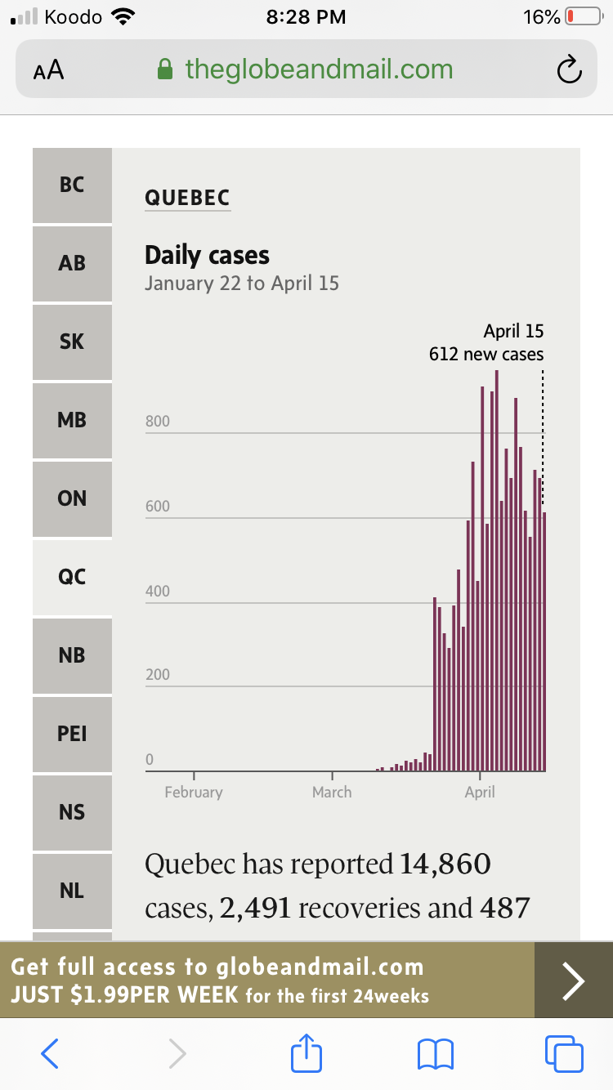
It appears on that graph dated April 15th that Quebec’s curve is the most problematic. In terms of BC, NB and Québec, did you take note of how differently the y axes are labelled. It is deceiving IF you don’t take the time to read how the axis are labelled. Scroll back up and take note of that! What was the highest number of cases on a single day for each of the three provinces?

7.Read the following article. Click on the provinces to see specifics on the graph (ie. Click on NB to see how long it takes for NB to double the number of cases)
https://globalnews.ca/news/6826198/coronavirus-good-news-curve-canada-graph/

- The Government of New Brunswick is tracking data daily on COVID-19 in New Brunswick. Read through the information contained in the link below to test your knowledge of COVID-19. There are excellent FAQ and provincial data that is updated daily.

https://www2.gnb.ca/content/gnb/en/corporate/promo/covid-19.html#faq

- Having read the GNB data, Is New Brunswick testing a population or a sample? How do you know? Why one over the other? (sample over population or population over sample). Explain in your notebooks on p.62.

Obviously, they are testing a sample. It is not possible (time, expense etc.) to test every single person in the entire province (population).
- Yesterday, April 28th, 2020, ***Dr. Russell, Chief Medical Officer for the province of NB announced that our province had no new confirmed cases of COVID19 for the last 10 consecutive days. Way to go, New Brunswick! Keep that curve flat and only at 118 cases.

