Lesson # 20 Statistics Canada
Stats and Probability (Outcomes SP 1,2,3,4,5,)
SP1: Describe the effect of the following on data collection: • bias • use of language • ethics • cost • time and timing • privacy • cultural sensitivity

We hear and read A LOT! Is everything we hear, see, and read actually true?
Let us start by watching this video. It was on tv all the time when Mrs. Hayes, Mr. Hopper and your parents were young, and everybody was fascinated by the house hippo!
https://www.youtube.com/watch?v=TijcoS8qHIE

I like how at the end they ask you to question what you see on tv. That is because we didn’t have the internet back then. We didn’t even have cable tv! (Just 2- maybe 3- channels.) Today, we need to question everything we hear, see, and read- be it on paper, online, via video, social media etc. We all know that not everything we hear, see, and read is actually “true” or what we could refer to as a “valid source of information.”
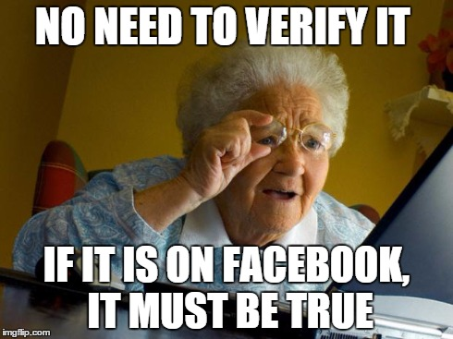

Let’s end that with a giant NOT! News chasers, Instagram, FB etc. are NOT reliable sources.
What about Wikipedia?
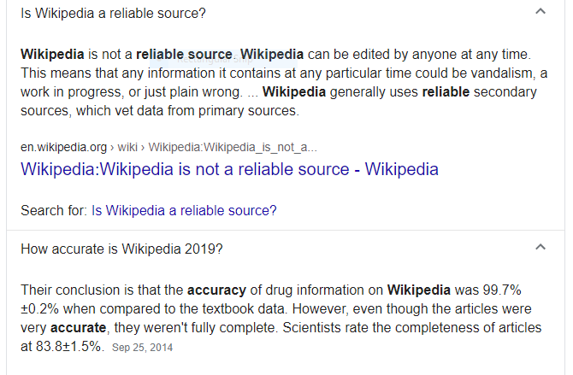

What are our best sources of information?
- Government sources are great sources of information based on science and data.
- Many newspapers, online articles etc. will cite their sources and you can google them to determine credibility.
- United Nations, World Health Organization etc. are excellent sources of documented valid statistical data.

How to Evaluate Websites
Unlike most print resources, much that appears on the web has not gone through a peer review, or even an editing process. Consider questions such as:
- What institution or Internet provider supports this information?
  - Look for a link to the homepage.
- Does the author provide background information relating to his/her authority for expertise in this area?
  - If the author's credentials are not clear from the site itself, search in the library or on the Web for information about the author and his/her publications.
  - What does the ‘About Us’ button tell you?
- When was this information last updated?
  - Look at the top or bottom of pages. Is it current enough to be of use for your topic?
  - Check links - are they up to date? Do they work?
- What is the site's domain?
  - Look at the endings of URL addresses
  - The following list shows several sites defined by their domain. Generally speaking, .edu, .gov or .org domains are more reliable than .com.
    - .edu - educational institutions
    - .gov - government bodies
    - .org - organizations, non-profit
    - .com - commercial businesses, for-profit
    - .net - organizations related to the Internet itself
    - .ca - sample country, i.e., Canada
    - . gc.ca - Canadian government
Source: University of Waterloo
When completing research, there are 7 problems to avoid: bias, timing, cost, cultural sensitivity, ethics, privacy, confidentiality and use of language
#1. Think of it like this- I want to come up with a question that I can research. Consider this question: “Are you an average teenager?”
Is that a “good” question? Think about this… Yes? No? Why or why not?
How you and I and Mr. Hopper all define average can differ. I can think in terms of average teenage behavior. You might think in terms of height. Mr. Hopper might think of it more in terms of intellect. Because we all interpret the question differently, we will answer differently. Language must be clear. YOU NEED A CLEAR QUESTION THAT EVERYONE UNDERSTANDS AND INTERPRETS THE EXACT SAME WAY.
Ex. The Canadian Census asks very specific and clear questions: What is your address? How many people live in your household? What language is spoken most at home. These are very clear questions. Why do you think it is only done every 5 years? TIME and COST. It takes years to compile the data. It also takes a huge budget to complete the census. The next one is in 2021!

#2. Can I ask Elizabeth, face to face what her favorite course is? Firstly, that puts a lot of pressure on her and I am influencing her because she knows that I want her to say Math. I can avoid bias and respect privacy if I ask my question on a sheet of paper during G3 (so I am not doing it during Math class and trying to sway you to profess how much you LOVE my class!)

#3. If I want class data on smoking, can I just say, “Raise your hand if you have ever smoked a cigarette (inhaled)?” What if I preface it with, I am going to ask you a confidential question and I promise to not contact your parents. 10/25 students raise their hands and I have data for my class. Is this data valid? Was everyone honest? Raising your hand does not protect PRIVACY. What if I note the names of those 10 kids and call all their parents and share this information? That would not be ETHICAL if I had given my word. Think of the Student Perception Surveys that you do every year. They are anonymous. No names. No one identifies handwriting because everyone bubbles in a scantron sheet the same way. The data is used not to contact parents but to provide general data about the lifestyles of teenagers at SRHS, in ASD-S, in NB and in Atlantic Canada.

The Government of Canada and Statistics Canada work very diligently to protect personal information provided in the Canadian Census.
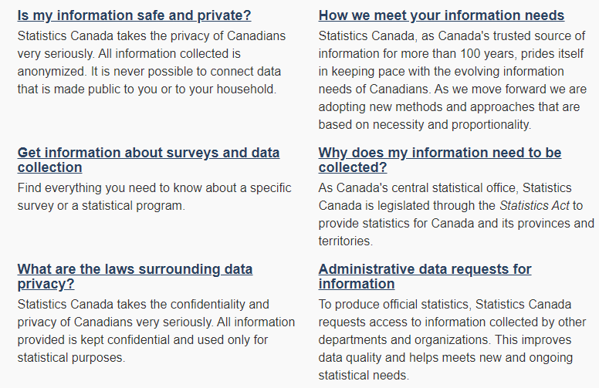
Source: Statistics Canada

#4. Cultural Sensitivity refers to respecting different cultures and lifestyles. For example, the Canadian Census would not ask what church you attend. Why? Because not everyone identifies as religious and/ or attends church, some attend mosque, synagogue etc.

Visit the Stats Canada Community Profiles website at the link below:
https://www12.statcan.gc.ca/census-recensement/2016/dp-pd/prof/details/page.cfm?Lang=E&Geo1=CSD&Code1=1305022&Geo2=PR&Code2=13&Data=Count&SearchText=Sussex&SearchType=Begins&SearchPR=01&TABID=1&B1=All
Answer the following questions in your notebook on p.61, by referring to the above link:
- What was the population of Sussex in 2016?
- What is the population density per km²?
- The population of Sussex aged 15-19 was only 255. Why? (Especially given that we have 700 teenagers at SRHS).
- What is the average size of a family in Sussex?
- What does that number (#3 above) represent?
- How many non-official languages are spoken in Sussex?
- What was the average total income in Sussex in 2016?
- Regarding #6 above, which gender earned more?
- How many people in Sussex have a post-secondary certificate, degree, or diploma?
- How many people worked from home in 2016?
- Scroll up to the top of the table and change NB to your town (Norton, Sussex Corner etc.) and note 3 significant differences between Sussex and your community. (If you live in Sussex, pick any other place of your choosing).

Once you have finished, scroll down, and check your answers below.

ANSWERS
1.What was the population of Sussex in 2016? 4282
2.What is the population density per km²? 478.3/km²
3.The population of Sussex aged 15-19 was only 255. Why? Especially given that we have 700 teenagers at SRHS. It only counts people who live within the town limits of Sussex.
4.What is the average size of a family in Sussex? 2.7
5.What does that number (#3 above) represent? When they add up all the families and divide, they end up with a decimal. It simply means that they the mathematical average family is 2.7 people. It does not mean having part of a person.
6.How many non-official languages are spoken in Sussex? 85
7.What was the average total income in Sussex in 2016? $36 525
- Regarding #6 above, which gender earned more? Male $45 094 compared to female $ 29 339
- How many people in Sussex have a post-secondary certificate, degree, or diploma? 1140
- How many people worked from home in 2016? 70 (Imagine that number right now!)
- Scroll up to the top of the link and change NB to your town (Norton, Sussex Corner etc.) and note 3 big differences between Sussex and your community. (If you live in Sussex, pick any other place you want. ***These answers will vary but I LOVE these community profiles. Play around with Toronto and Vancouver and even Moncton and Saint John.

